 | Final Examination  Semester 2, 2012  COMP.6108 Database Design and Development
School of Computing, Technology & Communications | Date: Thursday 08 Nov 2012  Commencement Time: 03:00 pm  Time Allowed: 2 hours plus 10 minutes reading time  Weighting: 40%  Marks: 100

Instructions:
 | 1. | No writing or highlighting is permitted during reading time.
 | 2. | Commence each SECTION on a new page.
 | 3. | CLOSED BOOK.
 | 4. | Calculators and any form of dictionary are NOT PERMITTED.
 | 5. | Write answers to all questions on the paper provided.
 | 6. | ALL diagrams must be drawn neatly using a template or a ruler.
 | 7. | Take care with your handwriting, as illegible writing will not be marked.
Learning outcomes: 1,2,3,6

Summary of paper:
Section | Topic | Marks
A | Theory | 20
B | Analysis | 30
C | Application | 50
 | TOTAL MARKS | 100

SECTION A THEORY 20 MARKS

A.1 What are the three layers of the three-tier client/server database architecture? Give an advantage and disadvantage of three–tier architecture.
. [3 marks]

A.2 Explain the difference between ‘transient data’ and ‘periodic data’ and give an example for each. [3 marks]

A.3 In the context of the Enhanced ERD, explain the ‘completeness’ constraint and the ‘disjointness’ constraint, using two examples. [2 marks]

A.4 Explain new trends in the use of databases for business problem solving with reference to star schema model of data warehousing. [3 marks]

A.5 Describe the purpose and the main goal of physical database design.
[3 marks]

A.6 Explain the use of index files to improve the performance of an SQL query using an example. [3 marks]

A.7 Explain the purpose of using data cubes in a data warehouse, giving one example of a data cube. [3 marks]

SECTION B ANALYSIS 30 MARKS

B.1 A car rental company has many clients and needs to keep records of its clients (name and phone number) and the cars rented out by the clients. A client may or may not have a current licence. A client may rent zero, one or many cars but has to have a licence. Licence (number, date and type) and Car (registration number, make and model) information are only stored for clients of the company.

The following two Enhanced Entity Relationship diagrams have been put forward as possible models for this situation.

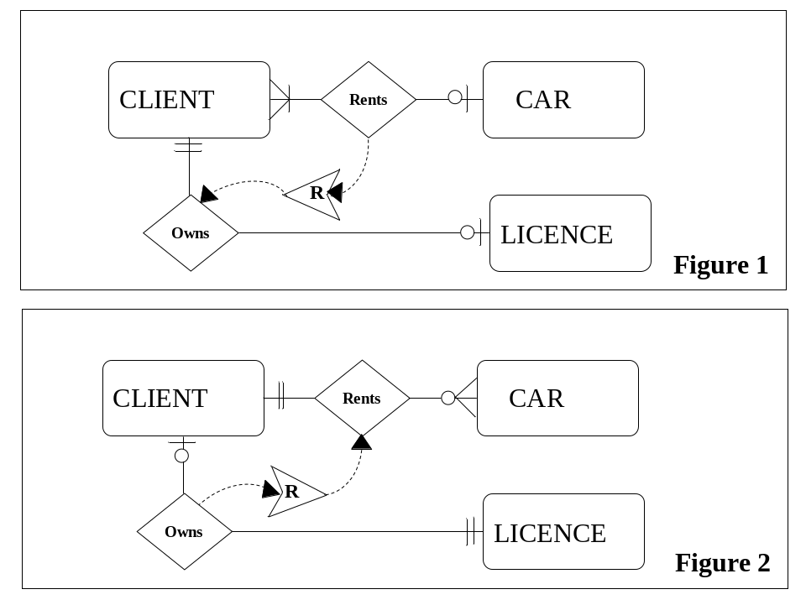

a. For each of the entities in the two Enhanced ERDs, list the PK, FK and any other attributes that you consider to be necessary. [4 marks]

- Discuss how well the Enhanced ERD in figure 1 models the requirements.
[3 marks]

- Discuss how well the Enhanced ERD in figure 2 models the requirements. [3 marks]

d. You are told that clients can rent a maximum of three cars. Draw an Enhanced ERD to model this situation (fix any faults that you may have identified). Show optionality and cardinality on your diagram.
[4 marks]

B.2 The following ERD models a database which keeps tack of suppliers supplying parts to an organisation.

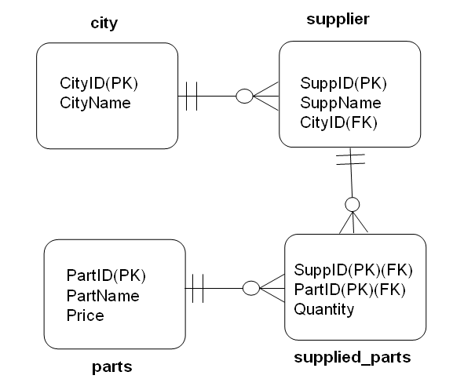

The following Transact-SQL code (with the ON DELETE clause) should create four tables: city, supplier, parts and supplied_parts. This code was written by a junior programmer and has many mistakes.

CREATE TABLE city (
CityID int NOT NULL,
CityName varchar(10) NULL,
CONSTRAINT city_cityID_pk PRIMARY KEY(CityID) );

CREATE TABLE supplier
(SuppID int NOT NULL,
SuppName varchar(10) NULL,
CityID int NULL,
CONSTRAINT supplier_SuppID_pk PRIMARY KEY(CityID),
CONSTRAINT FK_city_supplier FOREIGN KEY(SuppID)REFERENCES city(CityID) ON DELETE SET NULL);

CREATE TABLE parts
(PartID int NOT NULL,
PartName varchar(30) NULL,
price int NULL );

CREATE TABLE supplied_parts
(PartID int NOT NULL,
SuppID int NOT NULL,
Quantity int NULL,
CONSTRAINT supplied_parts_pk PRIMARY KEY(PartID, SuppID),
CONSTRAINT FK_parts_supplied_parts FOREIGN KEY (PartID) REFERENCES parts(PartID) ON
DELETE CASCADE);

a. Discuss whether the SQL constraints accurately represent the model or not and identify any missing/additional constraints. Justify your answer and state any assumptions made. [8 marks]

b. What is the effect of the ON DELETE CASCADE and ON DELETE SET NULL constraints? In your explanation use the tables above as an example. [4 marks]

c. Explain what is meant by referential integrity of a database using an example from the above code.
[4 marks]

SECTION C APPLICATION 50 MARKS

C.1 A private investigation agency maintains details about its employees (employee number, name, and address), clients (client Number, name, address and phone number) and their cases (description and status).

A client can open not more than 5 cases at a time but may occasionally not have any cases open. After a new case is opened, operatives can be assigned to it. The operatives are usually employees of the agency. A case must have at least one operative assigned to it. After an operative has been assigned to a case, the operative may obtain a number of equipments for the assignment. An equipment is either being used on an assignment or not being used at all.

Details about operatives (name, cell phone number and hourly rate) are also maintained. An operative may be assigned to several cases at the same time.

- Draw a normalized Enhanced E- R Diagram for this database. On the Enhanced ERD, name relationships and show optionality and cardinalities. You must indicate subtypes, business rules such as limitations on the diagram. Show all necessary attributes of each entity and clearly mark primary keys, and foreign keys. State and justify any assumptions made.
[25 marks]

C.2 A database has the following relations:

DEPARTMENT (DeptID, Name, Location)
EMPLOYEE (EmployeeID, LastName, FirstName, Address, Status, DeptID, EmployeeTypeID)
PROJECT (ProjectID, ProjectName, Description)
EMPLOYEEPROJECT (EmployeeID, ProjectID, Completed)
EMPLOYEETYPE (EmployeeTypeID, Description, Salary)

The ERD for this is as follows:

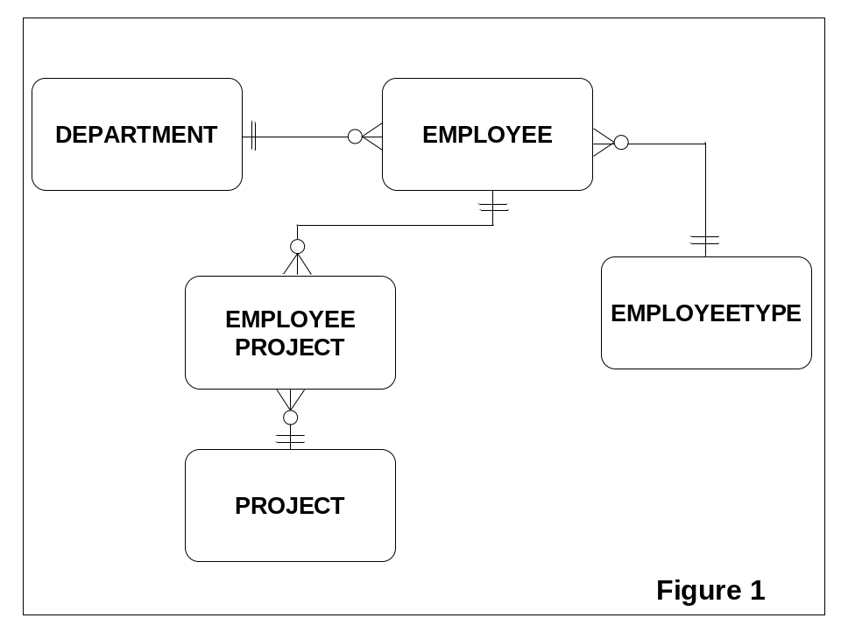

The processes that make up the help desk database system are:
- Reporting all departments by location
- Reporting all employees by employee type (employee type description, employee’s id and employee’s status)
- Reporting all employees by department (department name, employee’s name, and employee’s address)
- Reporting all completed projects (employee id and project name)
- Reporting all incomplete projects (employee id and project name)

C.2 a. Assuming that the tables hold large amounts of data, discuss possible index usage on tables to speed up data retrieval. You must clearly state the name(s) of attribute on which each index file is created. [5 marks]

b. The manager says that the two reports, ‘all completed projects’ and ‘all incomplete projects’ often run simultaneously and should perform as fast as possible. What are your suggestions for physical design? Discuss any adverse effects that your proposed design may have.
[4 marks]

c. The manager says that the two reports on the employee table, ‘employees by employee type’ and ‘employees by department’ often run simultaneously and should perform as fast as possible. What are your suggestions for physical design? Discuss any adverse effects that your proposed design may have. [4 marks]
C.3 The following sample data shows data for the fields needed to answer the questions below:

EMPLOYEETYPE

EmployeeTypeID | Description | Salary
ET001 | Manager | 80000
ET002 | Team Leader | 45000
ET003 | Accounts clerk | 20000
ET004 | Accountant | 80000

EMPLOYEE

EmployeeID | LastName | LastName | EmployeeTypeID
E0001 | Smith | John | ET002

a. Write an advanced Transact-SQL statement to determine the lowest and highest salary. The employee type’s description should be included in the output.
[4 marks]

Given the sample data above, the output should be:

Description Salary
---------------- ---------
Manager 80000
Accountant 80000
Accounts clerk 20000

b. The following Transact-SQL code should create a Function called Get_Total_Salary(). Identify two errors in it and rewrite. [6 marks]

CREATE FUNCTION Get_Total_Salary() RETURNS varchar
BEGIN
DECLARE @total_Salary int
Select @total_Salary = SUM(salary) from EMPLOYEETYPE
RETURN @total_Salary

- Write a single Transact -SQL statement that selects the description of employee types with the highest salary from the EMPLOYEETYPE table.
[2 marks]
Given the sample data above, the output should be:

Description
----------------
Manager
Accountant

